**Ordinary Regression Model building**

Sree Sarada Alapaty

HAP 719

|  |  |
| --- | --- |
| Question | Yes/No |
| 1. | Yes |
| 2. | Yes |

**Question 1.** The following data provide many factors that affect vaccination rates for COVID-19 in a county in United States.  Use hierarchical modeling to see which subset of factors explain largest portion of variance in getting Complete Series Vaccination rate.

1. Initially explain variation in Complete Series Vaccination rates by demographics (including age, race, gender) of the county's residents.  Report the percentage of variation explained.
2. Explain variation in Complete Series Vaccination rates by demographics (age, race, gender), and social determinants (including high school completion rate, percent nor proficient in English, percent employed, percent of children in poverty, and median household income).  Report the percent of variation explained.
3. Explain variation in Complete Series Vaccination rates by demographics (age, race, gender), social determinants (including high school completion rate, percent nor proficient in English, percent employed, percent of children in poverty, median household income) and health of residents (including percent population disabled, life expectancy, percent population having premature morbidity).  Report the percent of variation explained.
4. Explain variation in Complete Series Vaccination rates by demographics (age, race, gender), social determinants (including high school completion rate, percent nor proficient in English, percent employed, percent of children in poverty, median household income), health of residents (including percent population disabled, life expectancy, percent population having premature morbidity), and political leaning of the population (including republican leaning, democrat leaning).  Report the percent of variation explained.
5. Does a county's political leaning affect vaccination rates?

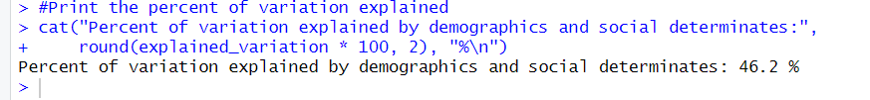

**Question 2.**

1. Using only independent variables measured in 2015 predicts incidence of diabetes in the county. Report the percentage of variation explained.
2. Using only independent variables measured in 2016 predicts incidence of diabetes in the county. Report the percentage of variation explained.
3. Using both independent variables measured in 2015 and independent variables measured in 2016, predict incidence of diabetes in the county. Report the percentage of variation explained.
4. List variables that have an impact on incidence of diabetes within a year.
5. List variables that have an impact on incidence of diabetes within 2 years.

